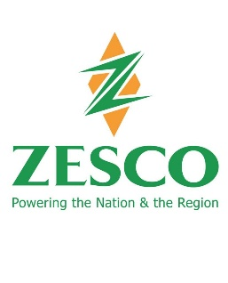

FOR IMMEDIATE RELEASE

JANUARY 13, 2023

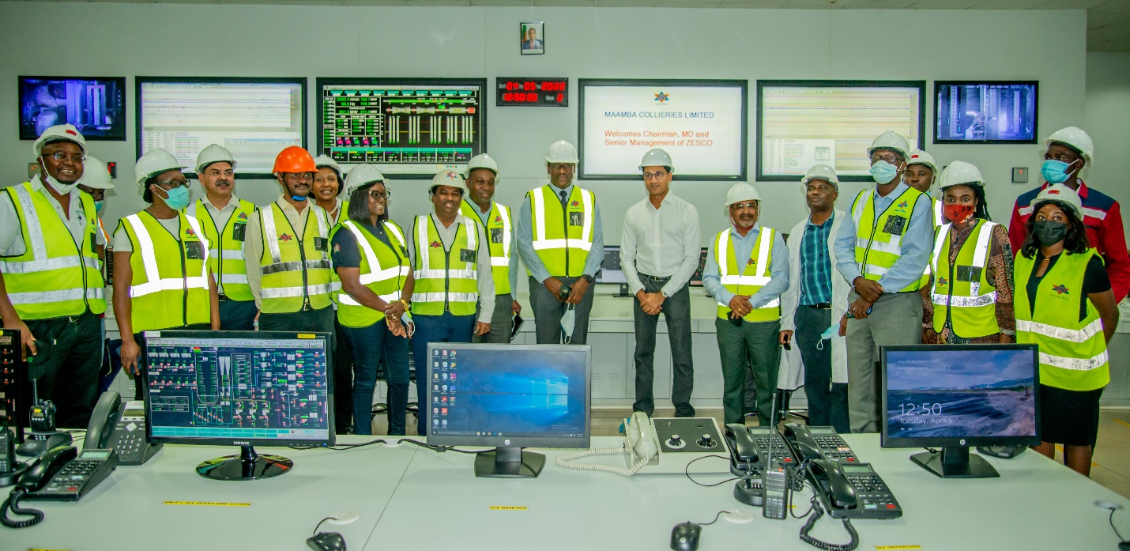

**MAAMBA COLLIERIES LTD AND ZESCO LIMITED JOINT CLARIFICATION ON MAINTENANCE OUTAGE**

LUSAKA, ZAMBIA – Maamba Collieries Limited and ZESCO Limited jointly clarify that the current shutdown of one of the two 150MW units for Maamba Collieries Limited’s 300MW Thermal Power Station is due to routine planned maintenance and strongly refute suggestions in some quarters, that the maintenance is being used as an ‘arm-twisting’ mechanism by Maamba Collieries to demand funds owed to them by ZESCO Limited.

The two companies have recently cemented a new spirit of partnership and collaboration following an agreement on an amicably revised tariff and resolution of a legal dispute over outstanding payments due to Maamba Collieries Limited.

The generator unit maintenance work was originally scheduled to begin earlier in December 2022, but was rescheduled to January 4, 2023, at the request of ZESCO Limited. This was in the hope of positive water inflows into Lake Kariba. The work being undertaken is essential maintenance that had already been postponed and is vital to ensure the safety and long-term operational efficiency of the critical equipment of the plant. The maintenance is expected to be completed by January 19 2023.

Maamba Collieries Limited has assured that every effort is being made to bring the power generating unit back into operation at the earliest, to lessen the impact of the load shedding.

(Issued By)

Matembo M. Lisimba Commodore PJ Sudhir (Retd.)

Director Corporate Support Services Head Corporate Affairs

ZESCO LIMITED MAAMBA COLLIERIES LTD.