FOR IMMEDIATE RELEASE
17 JANUARY 2023

MCL COMPLETES SCHEDULED MAINTENANCE
THREE DAYS AHEAD OF SCHEDULE

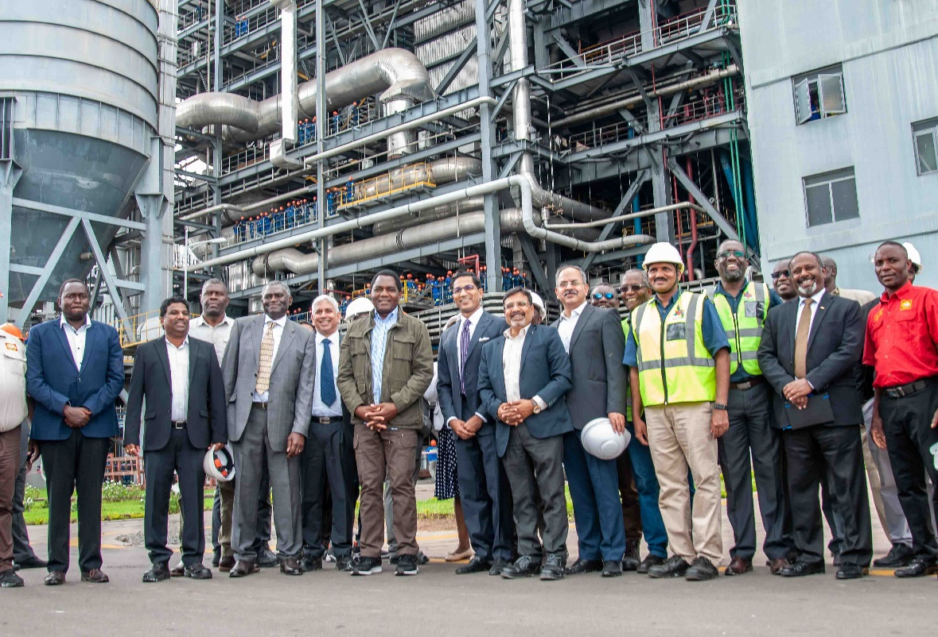

SINAZONGWE, ZAMBIA – Maamba Collieries Limited (MCL) has completed its scheduled maintenance works on one of its two 150 MW units at the coal-fired thermal power plant three days ahead of schedule and has since resumed operations at full capacity and supplying full power to ZESCO.

MCL has upheld its commitment made to the GRZ and ZESCO, during His Excellency the Republican President of Zambia Mr. Hakainde Hichilema’s visit to Maamba on 8th January 2023, to commence operations well before the scheduled date of 20th January 2023. His Excellency inspected the plant to obtain a better understanding of operations of the thermal power plant and discuss how best such maintenance works should be done going forward without disrupting the energy supply.

“We are happy to inform the nation that the unit was started up and synchronised with the national grid at 0930 hrs on 17 January 2023. Both150 MW power units at Maamba Collieries are now running at full capacity, thanks to sustained efforts by the maintenance teams. The teams worked tirelessly day and night and deployed additional manpower to bring the unit back online three days ahead of the scheduled date for start-up” said MCL CEO Lt Col Cyrus Minwalla (Retd).

“Reducing three days in a 16-day scheduled maintenance shutdown (earlier scheduled up to 19th January) was a herculean task and required our technical teams to work round the clock to bring the unit back online at the earliest, to lessen the impact of the load shedding. This would not have been possible without the support from ZESCO and the GRZ,” he continued.

The shutdown of the unit, which had earlier been rescheduled on request by the utility, was taken up to allow critical maintenance works, essential for the safety and long-term operational efficiency of the Thermal Power Plant. The modern, eco-friendly coal-fired power plant - the only one of its kind in Zambia – is complex with start of the art systems, and due to the nature of its operations, requires robust periodic maintenance as recommended by the Original Equipment Manufacturer (OEM) to ensure long term sustained availability.

“Maamba Collieries will continue working with ZESCO and ERB to ensure schedules for mandatory maintenance are adjusted as far as possible, to accommodate the national requirement of power and to minimise disruption of the electricity,” the company added.

Present shortage of rainfall in the country has reduced the power generation capacity from hydro plants drastically, and baseload energy producers like Maamba Collieries, which are not dependent on rainfall, play a key role in managing the energy deficit using resources available in Zambia without recourse to imports. The country's largest independent power producer is presently supplying more than 10 percent of the nation’s power, due to the reduced hydro-based generation in Zambia.

As energy is the prime mover of the economy and industry, Maamba Collieries Ltd., remains committed to alleviating the energy deficit, including capacity expansion to ensure increased diversity and energy security.
Ends

About Maamba Collieries Ltd

Maamba Collieries Limited (MCL), in Sinazongwe District in Southern Province, is Zambia’s largest coal mine and the nation’s biggest Independent Power Producer (IPP) with Zambia’s only coal-fired Thermal Power Plant (TPP).

The company operates a 300 MW (2 X 150 MW units) modern, eco-friendly coal-fired power plant - the only one of its kind in Zambia – with the capacity to supply 10 percent of the country's current installed electricity generation capacity.

MCL is owned 65 percent by Nava Bharat Singapore Pte. Ltd and 35 percent by ZCCM-IH, with some US$919 million invested since 2010.

The plant provides diversity in the nation's energy mix and contributes to the nation’s base load electricity demand with high-availability power that is independent of climate change.

For media inquiries please contact:
Gillian Langmead at Langmead & Baker Ltd.
+260 979 060705.
info@langmead.com

