FOR IMMEDIATE RELEASE
OCTOBER 10, 2022

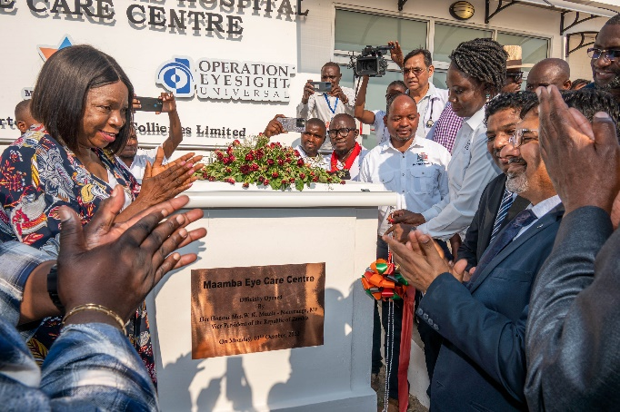

VICE PRESIDENT INAUGURATES MAAMBA EYE CARE CENTRE

MCL COMMUNITY VISION COMES INTO FOCUS

SINAZONGWE, ZAMBIA – Vice President W.K. Mutale Nalumango on 10th October, inaugurated the Maamba Eye Care Centre, set up by Maamba Collieries Limited (MCL), in partnership with the Ministry of Health and Operation Eyesight Universal.
Speaking during the inauguration Mrs. Nalumango said, “….through this partnership, the private sector has timely responded to the great needs of the people in Maamba township in Sinazongwe district of Southern Province, by providing a specialised eye clinic at Maamba General Hospital.”
“This developmental milestone is a clear demonstration of how ready the government is to partner with the private sector in eradicating the social services gap being experienced by the majority of the Zambian people.”
She further added, “This gesture should be emulated by other key players in the private sector. This public private partnership between the Ministry of Health, Maamba Collieries and Operation Eyesight Universal is such an example.”
Maamba Collieries Chief Operating Officer David Vijay Kumar said the Eye Care Centre, borne from the collaboration between MCL, the Ministry of Health, Maamba General Hospital and Operation Eyesight Universal (OEU), was established with the vision of offering modern specialised eye treatment to patients in Sinazongwe district and eventually the Southern Province. Notably, MCL’s investors Nava Limited (formerly Nava Bharat Ltd.), had earlier in 2012 donated US$500,000 for the construction of the Eye Clinic at the University Teaching Hospital (UTH) in Lusaka.
Preventable causes of blindness, such as trachoma, cataracts, and glaucoma, disproportionally affect people in low-to middle-income countries because of limited access to preventive and curative eye care. According to Operation Eyesight Universal, 90% of all cases of blindness are avoidable with the right healthcare and sensitisation.
Understanding the potential impact of the project, which is meant to provide quality eye care to the community and people of the province, Maamba General Hospital allocated a portion of its property to be transformed into the eyecare centre.
The project, which commenced in July 2017, entailed the refurbishment of the main operation theatre in readiness for the state-of-the-art equipment, upgradation of the centre’s outpatient facilities, procurement of equipment and training of nominated eye care specialists from the Ministry of Health.
Despite delays due to the COVID-19 pandemic, teams from MCL, district health authorities, Maamba General Hospital and Operation Eyesight met periodically to evaluate the progress at the project site. Meanwhile, MCL’s civil works department worked steadily in spite of the physical constraints imposed by the need to adhere to health guidelines and social distancing, and successfully refurbished the operating theatre and upgraded the clinic’s outpatient facilities, bringing completion of the project to its final stages.
By the end of 2021, MCL confirmed that the medical practitioners that were going to run the specialised clinic had completed their training. MCL also set aside funding to supplement Operation Eyesight’s investment and procured modern eyecare and treatment equipment required for the centre that has since been positioned and trials conducted, culminating in today’s inauguration of the Eyecare Centre.
Expressing satisfaction at the culmination of realising MCL’s vision for the Eyecare Centre, Maamba Development Trust Manager Jethro Sikalunda, who is responsible for implementing the company’s CSR Initiatives, said, “It brings us immense joy to finally see this ultra-modern facility complete and officially inaugurated. Progress was a bit slower than we would have liked because of the slow-down of activity during the pandemic, but teams from all our partners worked extremely hard to surmount these challenges and complete this much-needed centre in good time.”
Speaking at the event Mr Kumar added, “We are extremely happy to have worked hand-in-hand with officials from the Ministry of Health and District Health authorities, Operation Eyesight as well our long-term partner Maamba General Hospital in successfully establishing this facility at an overall cost of around US$1.3 million. We hope the people of the community and indeed Southern Province will avail the facilities, available for the first time in this remote area, at this modern and state-of-the-art Eyecare Centre.”
The Eye Care Centre is one of many projects being run by the company’s Maamba Development Trust to make a sustainable difference in the community, in keeping with MCL’s CSR tagline …Making a Difference.

Ends
About Maamba Collieries Ltd

Maamba Collieries Limited (MCL), in Sinazongwe District in Southern Province, is Zambia’s largest coal mine and the nation’s biggest Independent Power Producer (IPP) with Zambia’s only coal-fired Thermal Power Plant (TPP).

The company operates a 300 MW (2 X 150 MW units) modern, eco-friendly coal-fired power plant - the only one of its kind in Zambia – with the capacity to supply 10 percent of the country's current installed electricity generation capacity.

MCL is owned 65 percent by Nava Bharat Singapore Pte. Ltd and 35 percent by ZCCM-IH, with some US$919 million invested since 2010.

The plant provides diversity in the nation's energy mix and contributes to the nation’s base load electricity demand with high-availability power that is independent of climate change.

For media inquiries please contact:
Gillian Langmead at Langmead & Baker Ltd.
+260 979 060705.
info@langmead.com

